Alice In Wonderland
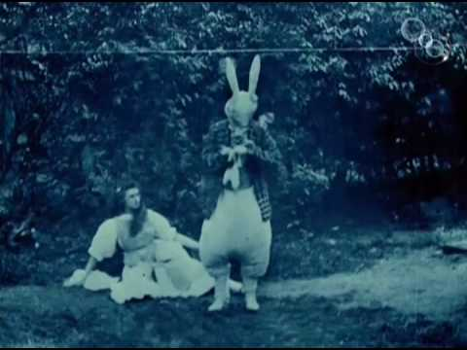
A young woman in an elaborate dress stares in astonishment at a large white rabbit which is consulting his pocket watch. Bizarre – but utterly recognisable: possibly among the most recognisable images in the world.
It is a measure of the cultural impact of Lewis Carroll’s story of 1865 that British film-making pioneers Cecil Hepworth and Percy Stow should fix on it for the subject of a film as early as 1903: just eight years after the first motion pictures were publicly screened (in Paris in December 1895). On the other hand, it is appropriate that a new technology should be applied to Alice’s Adventures In Wonderland, given Carroll’s own early adoption and championing of photography in the 1850s and 1860s. The vanishing and reappearing of the Cheshire Cat are said to have been inspired by the appearance and potential disappearance of images created through the ‘wet collodian process’ he preferred when developing his photographs. Indeed, the placing of John Tenniel’s illustrations as a part of the printed text rather than on separate plate pages was unusual and allowed greater harmony between the words and images than in most books of the period, while the pictures of the Cheshire Cat first coming and then going on the front and reverse of a single page in Chapter 6 has the quality of a ‘flip-book’ - a precursor to moving image technology.
The creation of a 12-minute film version of the fantastical story of Alice’s Adventures In Wonderland represented a considerable advance for Hepworth and Stow. In 1900 their subject matter was altogether less sophisticated with How It Feels To Be Run Over (Hepworth Manufacturing - How It Feels To Be Run Over (1900) - YouTube) reflecting the trend for short, sensational film sequences that relied on audience’s lack of sophistication for a lot of their impact.
That the Hepworth and Stow film has survived is miraculous. Only one copy exists and despite skilled restoration by the British Film Institute of the original highly unstable negative, some of the film has been lost and it now runs for just over nine minutes.

Activity 1.
The following details relate to Lewis Carroll’s novel and Hepworth and Stow’s subsequent film version. The facts can be shared out among students so that each person or pair has a fact for which they are responsible. They need to try to commit the fact to memory, making it their own ideally, by putting it into their own words as much as possible. Then, at a signal, everyone must move around the room sharing their ‘fact’ with others and listening in turn to the facts others tell them. This process can last between a minute and two. Afterwards, get students to repeat their facts for the class. A follow up could involve students attempting to create an actual line representing the relative importance of the facts or positioning of facts if they were to be a part of a written article about the novel and the first film it inspired.

- Lewis Carroll’s real name was Charles Lutwidge Dodgson.

- Lewis Carroll was born on the 27 January 1832.

- Lewis Carroll’s father was a county parson in Daresbury in Cheshire and later in North Yorkshire.

- Lewis Carroll’s mother gave birth to 11 children.

- Lewis Carroll was the eldest boy in the family. He had 10 brothers and sisters. He loved looking after his younger brothers and sisters and invented all sorts of games, magic tricks and puzzles for them.

- Carroll was very clever. He loved reading and mathematics.

- Lewis Carroll suffered from a slight ‘stammer’ – he called it a ‘hesitation’.

- Lewis Carroll managed to become a lecturer in mathematics at Christ Church College, Oxford. He stayed in that job for 25 years. His lectures were probably pretty dull.

- One of Lewis Carroll’s passions was the new ‘craft’ of photography. He took up the hobby in 1856 and became of the best early photographers. His pictures of Alice Liddell and her sisters Edith and Ina are among the most famous images ever taken.

- On July 4, 1862 Lewis Carroll and a Reverend Duckworth took the three Liddell sisters including Alice aged 10 for a rowing-boat ride on the Thames. It was a three-mile journey. It started a Folly Bridge. During it Carroll was asked to tell a story: Alice’s Adventures In Wonderland was that story.

- Alice Liddell begged Carroll to write the Wonderland tale down. He did so, adding illustrations too. It was first called ‘Alice’s Adventures Underground’.

- Before Alice received her copy – see Number 9 above, Carroll was already preparing it for publication and expanding the 15,500-word original to 27,500 words. He added the episodes about the Cheshire Cat and the Mad Tea-Party. (Source: Martin Gardiner: The Annotated Alice.)

- According to Martin Gardener, Alice changes in size 12 times during the course of the story.

- In 1926 Alice Liddell chose to sell the original copy of Alice’s Adventures Under Ground that Lewis Carroll created for her between 1863-64. It made £15,400 and was sold to an American.

- The original Alice In Wonderland It was sold to an American and travelled to America but was given back after the Second World War. The manuscript is now in the British Library.

- Only one copy of the original 1903 film is known to exist and some of this one copy has been lost – there is only a fleeting glimpse of the dog Alice meets in the magic garden, for example.

- Cecil Hepworth was born in Lambeth, in present-day South London. His father, Thomas Cradock Hepworth, was a famous magic lantern showman and author.

- In the late 1890s Cecil Hepworth set up a production company in Surrey. It produced as many as three films a week. Between 1901 and 1903 he collaborated with Percy Stow – a specialist in trick films. The company’s Alice in Wonderland demonstrates Stow’s influence.

- Among Hepworth’s most famous films is Rescued by Rover (1905), co-directed with which features as its ‘star’ a collie dog. It made a lot of money. The film is now regarded as an important development in film grammar, with shots being effectively combined to emphasize the action. Hepworth was also one of the first to recognize the potential of film stars, both animal and human, with several recurring characters appearing in his films.
- Cecil Hepworth’s company continued making popular films into the 1920s. Thanks to his rather (by then) old-fashioned film style and also some poor financial decisions, his company went bust in 1923. One dreadful consequence was that all of the original film negatives in Hepworth's possession were melted down by the receiver in order to sell the silver. Some of his films, thought lost, have been found in archives around the world.

Activity 2
The following list sets out some possible reasons why, at this very early point in the history of English cinema, Hepworth and Stow chose to make a film of Alice In Wonderland. There are no right or wrong answers here – all you have to do is decide which order these suggestions should be in from most significant to least. You could share out these suggestions with classmates and create ‘a physical priority line’ which will involve some negotiation and discussion.
- The book Alice in Wonderland contains all sorts of strange incidents and characters providing an opportunity for special effects and elaborate costumes.
- The book Alice in Wonderland had by 1903 already gained the reputation of a literary classic making a film of it likely to be a source of curiosity.
- Alice In Wonderland was an acknowledged children’s classic and as such any film of it was likely to appeal to family audiences in a way that other early cinema might not.
- Alice in Wonderland published in 1865, had by 1903 generated all sorts of spin-off merchandise. Lewis Carroll had even suggested a postage stamp case with illustrations by Tenniel of characters from his novel and had given approval for other illustrations to appear on a biscuit tin. This is the kind of context in which Hepworth and Stow decided to produce their film-version: a context filled with products that indirectly promoted their film.
- Early film suffered a bad reputation being associated with fair-grounds and other dubious spaces. Many early films were also rather risqué ‘what the butler saw’ type entertainments. By contrast, a film of Alice In Wonderland would do wonders for the new medium showcasing how it could create utterly respectable thrills and entertainment.
- Alice in Wonderland is a dream-like story in which the heroine finds herself in one strange location after another and this suited the restrictions imposed by early film technology which was rather static due to the cameras being very heavy and immovable.
- In Alice In Wonderland the story is largely insignificant. This rather episodic tale suited early film-making which was still some way from being able to tell complicated or tightly-woven narratives.
- The film Alice In Wonderland provided a wonderful role for 18-year-old May Clark who would act in some 22 silent era films and gain international fame as one of the cast in a later Hepworth film Rescued by Rover (1905). In those days everyone did everything during a film’s creation and Clark contributions ranged from creating special effects to carpentry.

Activity 3.
Watch the Hepworth and Stow film – available at Alice in Wonderland (1903) - Lewis Carroll | BFI National Archive - YouTube. If students know the original novel they could attempt to write a brief account of the sequences that the film includes and some that the film ignores (noting that Alice’s meeting with a puppy in Chapter 4 was filmed but is now among the sequences that are now lost). Their version of the film’s content can then be compared to the synopsis provided on the Wikipedia site: Alice in Wonderland (1903 film) - Wikipedia. Also, for those students that know the novel well, it might be interesting to note how the film alters the original and why these changes were made.

Why do you feel the following incidents were excluded from the Stow and Hepworth version of the story:

- Alice falling into a pool of her own tears where she encounters a number of other creatures.

- Alice meeting the caterpillar on top of a giant mushroom.

- Alice finds her neck stretching so that it extends into the trees and she frightens a pigeon which mistakes her for a snake.

- The game of croquet with flamingos as mallets and hedgehogs for the balls and with playing card-people bent over to create the hoops.

- The trial scene involving dozens of characters and assorted animals.

Activity 4
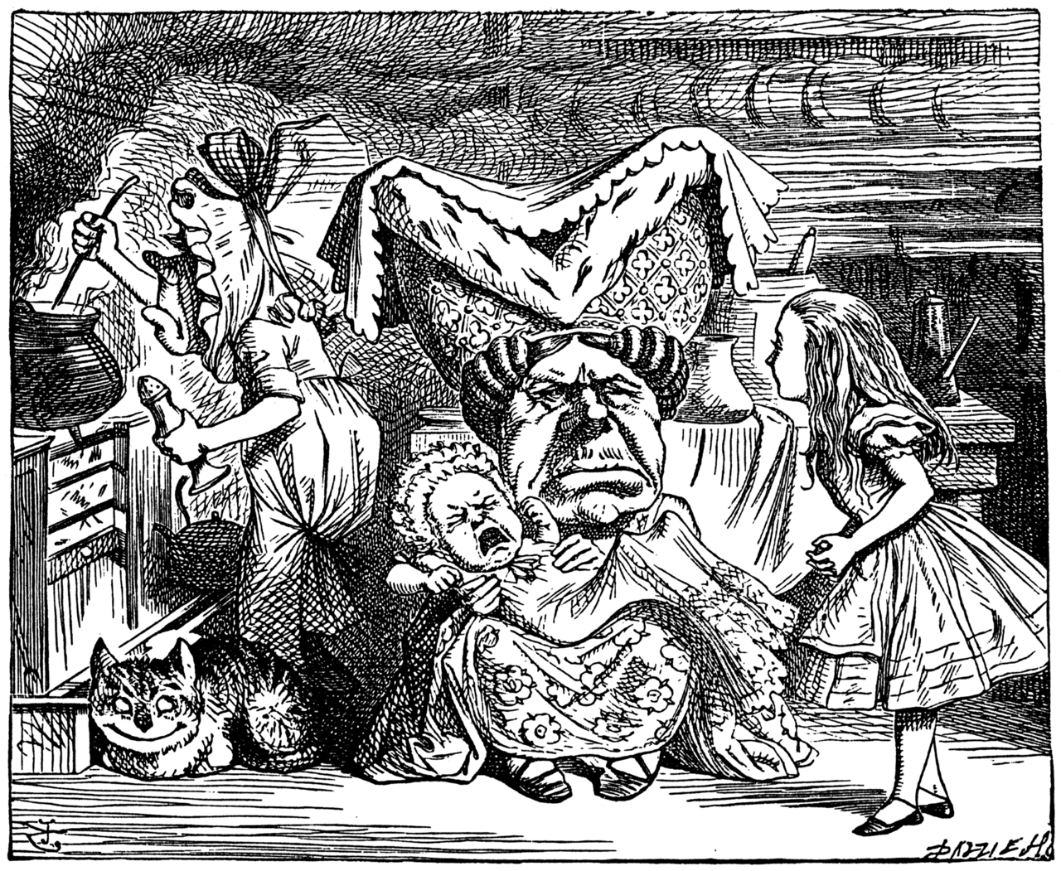
This picture is one of the original illustrations for Alice In Wonderland by the artist John Tenniel. The scene it depicts is Alice’s visit to the Duchess’ kitchen where the atmosphere is practically toxic thanks to the cook’s excessive use of pepper. In the film the same scene runs for about 40 seconds from 3.20-4.00 minutes. What elements of the Tenniel have influenced the scene in the film? What has been left out and what might have been the cause of such excisions?

Extend your research to other scenes in the Hepworth and Stow film and their equivalent Tenniel pictures. A simple search online for ‘Tenniel’s illustrations for Alice In Wonderland’ will provide plenty of images with which to work.

Activity
Students catalogue the special effects in the film and consider how pioneering they were and how similar effects still occur in films. Can we discuss the practicality of students attempting to create one or more of the special effects in the Hepworth and Stow film? Jump cuts , perhaps. Early Trick Films | Scotland on Screen

Activity 5
Early cinema can seem very strange if you have not seen anything like it before. This activity asks that you think about the ways in which films have become more sophisticated and what is ‘missing’ from this 1903 film that you would expect to find in a modern movie.
Consider the following:
- Camera angles and framing;
- Camera movement;
- The capacity of film to capture expressions and small gestures and other details;
- Sound effects;
- Dialogue;
- Great care over mise en scène – what is in a scene is rarely there by chance, whereas sometimes in the 1903 Alice In Wonderland some locations are far from ‘magical’ (clue: the backdrop to Alice’s encounter with the King and Queen of Hearts)
- The natural colour of people and things.

Activity 6
Having explored the possible limitations placed on early cinema by cumbersome camera equipment and the lack of sound and colour – it is very important to recognise how innovative a film like the 1903 Alice in Wonderland is not least because of the complexity of the story it attempts to tell, but also because of the special effects it showcases – many of them borrowed from early French pioneer of fantastic cinema Georges Méliès (1861-1938).

As you watch Hepworth and Stow’s film attempt to catalogue the times you observe any of these special effects:
- Objects and people vanish and reappear.
- A baby becomes a pig
- Alice appears to grow and shrink
- Elaborate painted (Matte) sets suggesting fantastic environments.
- Strange costumes
- Strange props
- Some scenes are coloured thanks to the practice of frame-by-frame hand-tinting.
- People manage ‘impossible’ interactions with creatures such as Alice and the Cheshire Cat in the tree.

Try to research online how some of these effects were created. Once excellent resource is
Visual and Special Effects Film Milestones (filmsite.org)

Activity 7
Most of the special effects and other camera techniques in the early 1900s had to be done in the camera, or in other words directors could not rely on the editing process to add a great deal to their film. This is especially true when it comes to camera angles and framing which were severely restricted because of the weight and rigidity of early cameras and the tripods on which they rested.

In this activity you are invited to study the scene in the Hepworth and Stow film in which Alice has to contend with a baby that turns into a pig. It runs from about 4 minutes in for about 19 seconds.

Now consider how you might have planned to film that scene using any/all of the following shots:

- Close ups – showing a face and the actor’s expression in detail
- An Extreme Close Up - showing something in special detail
- A reaction shot – in which someone reacts to something happening out of the frame
- A low angle shot - often used to make something appear bigger or imposing or to suggest the point of view of something or someone looking up at another.
- A tilt shot – where the camera tilts up or down to reveal something or someone.
- A travelling shot or tracking shot in which the camera moves alongside or with a character or creature to capture its movement.

Try to create a short ‘cartoon’ storyboard showing how you would plan to film this sequence.

Activity 8
An interesting aspect of the story Alice In Wonderland is the power it gives to its heroine. In some ways this is not surprising since Lewis Carroll designed the story for a seven-year-old Alice Liddell but her role in negotiating a path through Wonderland and coping with often disturbing events and people she encounters does mark her out as a particularly confident and strong-willed young girl at a time when women’s rights and opportunities were very limited. (Liddell’s father was a senior academic at Oxford, but none of his daughters at that time were allowed to study at the University.)

Given the subordinate and rather passive role in life that girls and women of her class were expected to fulfil, use the film version of Alice In Wonderland to catalogue how the ‘character’ Alice perhaps breaks from these constraints.

It is tempting to draw a parallel between the resourceful and unflappable character Alice and the actress playing her (May Clark): performing roles in front and behind the camera as both performer and a part of the production team at Hepworth’s Walton-on-Thames studio

